Bitrix Site Manager 6.x
Quick Guide to Selling Content
Contents
Introduction 3
Creating and configuring a user group 4
Creating Paid Content and Access Services 6
New Information Block Type 6
New Information Block: Paid Articles 7
Selling Subscription for Paid Articles 10
Creating the Access Subscription Catalog 10
Turning the Information Block into a Commercial Catalog 11
Adding Elements to the Catalog 11
Publishing Paid Articles 15
Creating the Articles Page 15
Creating the Full Article View Page 16
Configuring Access Permissions For Selling 18
Publishing the Subscription Catalog 20
Configuring the Web Store 23
Permissions for Orders 23
Setting Up a Client’s Personal Area 25
The Ordering Procedure 25
Managing Orders 27

Introduction
This guide is intended for novice users of Bitrix Site Manager. The guide contains a detailed description of the technology which enables users to sell content on their sites.
The content selling technology is built upon the access permission distribution, which is the basic principle of Bitrix Site Manager. Each user group is assigned a unique set of permissions allowing their members to obtain access to the specified information. When a visitor buys content, they are added to a user group whose members are allowed to access the paid content.
Hence, the content selling process comes to selling the user group access permissions. Access permissions may be sold for a definite period of time (subscription), or forever.
Generally, the content selling process can be described by the following sequence of actions:
- creating a user group allowed to access the paid information resources;
- switching the user group into the access permissions selling mode;
- creating and customizing a commercial catalog to be used for content selling;
- configuring the e-store;
- publishing the paid content for sell;
- receiving and processing orders.
In this document, we shall consider the process of selling the subscription for full articles.

Creating and configuring a user group
Since the content selling is based on granting membership in user groups whose members have required access permissions, the first thing to do is create and set up a user group whose membership is to be sold.
To create a new user group, do the following.
- Open a page containing the list of user groups: Settings > Manage users > User groups.
- Click the Add group button on the context toolbar. This will open a new group creation form (fig. 1.1).
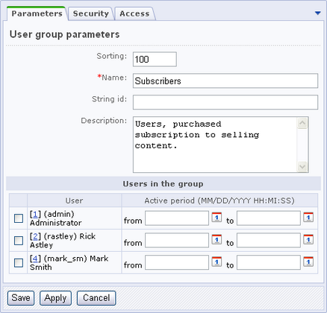
Fig. 1.1. User group creation form
- Specify the following parameters:
- Sorting: the sort weight of the new group. This value specifies the position of the user group name in lists. The less is the value, the higher the group name goes in lists.
- Name: the name of the new group. This field is required.
- String ID: the user group code (optional).
- Description: the arbitrary description of the group.
The Users in the group section is used to add existing registered users to the current group and specify the membership duration.
The Access tab (Fig. 1.2) specifies permissions of user group members to access the Control Panel functions of different system modules. Since the members of the Subscribers user group will be able to access information only in the Public section, leave the values of all fields set to <default>.
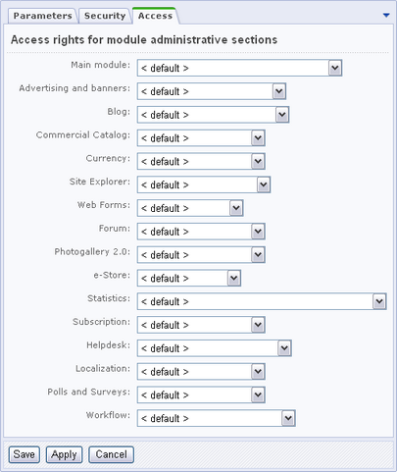
Fig. 1.2. Access permission management
- Click Save to create the new user group.

Creating Paid Content and Access Services
We shall use information blocks to create pain content (articles) and the paid resource catalog (subscription for articles). However, before we create information blocks of this kind, we have to set up a new information block type (call it, for example, Paid Content).

New Information Block Type
To create a new information block type, follow the instructions below.
- Open Content > Information blocks > Information block types in Control Panel.
- Click the Add new type button on the context toolbar. This will open the information block type creation form.
- Specify the ID and the name of the new type, for each of the languages installed in the system (Fig. 2.3).
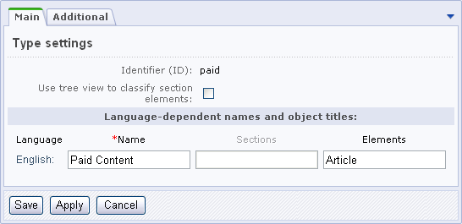
Fig. 2.3. New information block type creation form
- Save the new information block type.

New Information Block: Paid Articles
The Paid Articles information block will contain elements (articles) whose full text will only be available for paid users. To create this information block, do the following.
- Open Content > Information blocks > Information block types > Paid Content in Control Panel.
- Click the Add information block button on the context toolbar. This will open the information block creation form (Fig. 2.4).
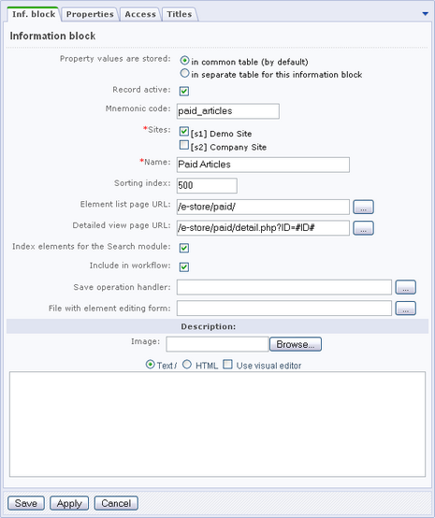
Fig. 2.4. New information block creation
- Fill in the form fields. Specify the information block name and select the site where it will be displayed. To get the detailed information about the creation of information blocks, please refer to the online help section.
Note! The form requires that you specify the section (directory) where you will save the pages to display the contents of this information block (e.g. /e-store/paid/).
- Click Save. A new form (Content > Paid Content) will open (Fig. 2.5).
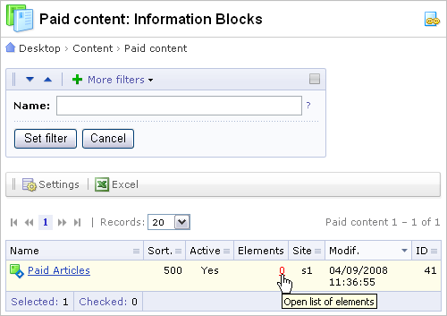
Fig. 2.5. The "Paid Content" information blocks
Now that we have created the information block, we can add elements to it.
- Click on the link shown as the number of elements (see Fig. 2.5) to open the form with elements of the Paid Articles information block.
- In that form, click Add element on the context toolbar. An information block element creation form will open (Fig. 2.6).
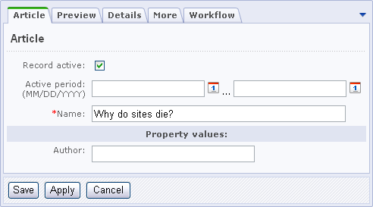
Fig. 2.6. Creation of a new element (article)
- Fill in the form fields in all tabs (the name, the preview text, the details etc.). You can find the detailed information about the creation of information block element in the online help section.
- Click Save. A new form displaying the elements of the Paid Articles information block will open (Fig. 2.7).
- Repeat these steps to add more articles if required:
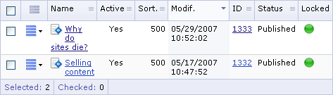
Fig. 2.7. Elements of the "Paid Articles" information block

Selling Subscription for Paid Articles
In order to enable visitors to purchase access to the paid site sections, we have to set up the following essential elements:
- create a catalog of paid access services;
- configure the services catalog for use as a content selling catalog.

Creating the Access Subscription Catalog
- Open the form showing the information blocks of the Paid Content type: Content > Information blocks > Information block types > Paid Content.
- Create a new information block, for example: Selling subscription to access paid articles. Click Add information block on the context toolbar to open the information block creation form.
- Specify parameters of the new information block (Fig. 2.8). This information block will be used to render the content selling services.
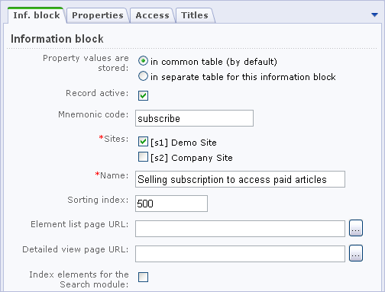
Fig. 2.8. New information block
- Save the information block by clicking Save.

Turning the Information Block into a Commercial Catalog
Now, perform the following actions to make the information block act as a content selling enabled commercial catalog.
- Open the Commercial Catalog module settings page (Settings > System settings > Module settings > Commercial Catalog).
- Switch to the Catalogs tab.
- Mark the options is a commercial catalog and Content Sale beside the Selling subscription to access paid articles information block (Fig. 2.9).
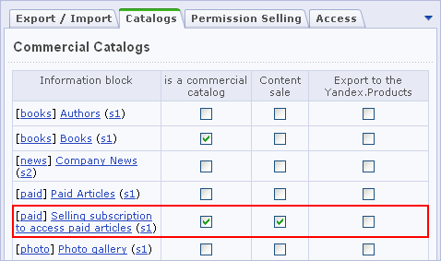
Fig. 2.9. Switching the information block to the content selling mode
- Apply changes by clicking Save.

Adding Elements to the Catalog
Now that we have made all the preparations, we can add elements (which are essentially the sale items) to the Selling subscription to access paid articles information block.
- Open the information block elements page: Content > Paid Content > Selling subscription to access paid articles.
- Click Add element on the context toolbar to open the element creation form (Fig. 2.10). Note that this form now contains the Commercial catalog section because we have configured the Selling subscription to access paid articles information block as a content selling commercial catalog.
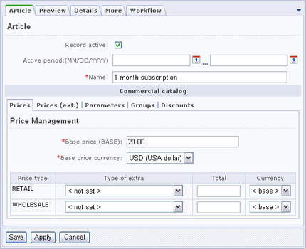
Fig. 2.10. Creating the article subscription
- Specify the subscription name (e.g. 1 month subscription) and the base price. Select the base price currency (Fig. 2.10).
- Scroll to the Commercial catalog section and click the Prices (etx.) tab (Fig. 2.11).
- Fill in the fields such that the discount becomes active for subscriptions over 6 months (Fig. 2.11).
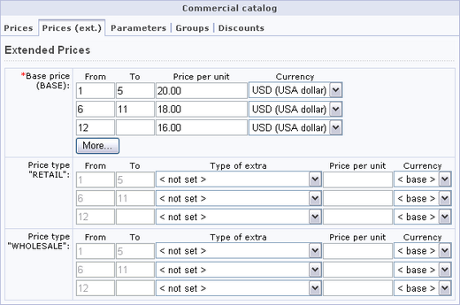
Fig. 2.11. Creating the subscription discount
Note! The types of prices and discounts/mark-ups have to be configured in the Commercial catalog module. To set up currencies, use the Currency module.
- Open the Parameters tab to specify the subscription parameters (Fig. 2.12).
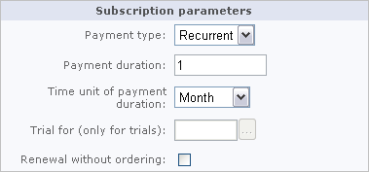
Fig. 2.12. Subscription parameters
Here, set the desired subscription parameters in the control group.
- Choose the required Payment type:
- 1) One-time: specifies that a customer buys a product item only once. No further actions on the order will take place.
- 2) Recurrent: a customer will be billed for the subscription renewal upon expiration.
- 3) Trial specifies that a customer buys a trial version (e.g. trial access). When the trial period expires, a customer will be suggested to purchase the full version of a product.
- The Payment duration field specifies the period of time on expiry of which the system will bill a customer again. This field should be filled for the Recurrent and Trial payment types.
- The Time unit of payment duration field defines the time unit used to measure the payment duration (month, day, hour etc.)
- If you have chosen a trial as the payment type, specify the full version in the Trial for field. When the trial period expires, a customer will be asked to purchase the specified product (full version).
- Renewal without ordering: If you have chosen the Recurrent payment type, enabling this option will calculate the total amount of order when renewing the subscription; however, no order record will not be created in the database. This option may be useful if small regular charges are to be drawn off the user internal account.
- Now click the Groups tab (Fig. 2.13). Here you will define a user group to which a user will be added whenever they buy the subscription. If you sell a time-limited subscription, set the subscription duration in the Active period field. When the specified period expires, a customer will be deleted from the group.
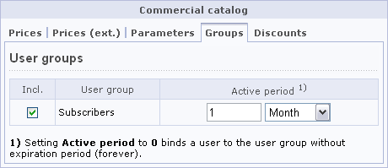
Fig. 2.13. Defining a user group allowed to access paid content
In this case, you can omit the preview and the detailed description: the subscription title will be perfectly informative. To get the detailed information about the creation of catalog items, please refer to the online help section.
- Save the subscription by clicking Save.
Repeat these steps to add the subscriptions for 6 and 12 months. Eventually, the Selling subscription to access paid articles information block will include the following elements:
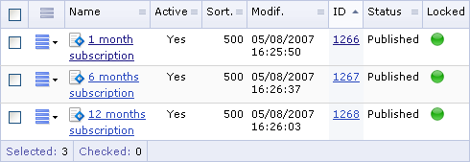
Fig. 2.14. Elements of the “Selling subscription to access paid articles” information block

Publishing Paid Articles
Elements of the Paid Articles information block can be easily displayed in the public section by adding visual components of the Information Blocks module to a page in the visual editor.
The following pages must be created to display paid articles:
- the articles page;
- the full article view page.

Creating the Articles Page
- Open the /e-store/paid/ folder in the site explorer.
Note! You must create this folder if it does not exist. You can get the detailed information about the creation of folders and sections in the online help.
- Now click New file on the context toolbar to open the file creation form (the visual editor).
- Find the List of news component in the components pane as shown below, and drag and drop it on the page (Fig. 3.15).
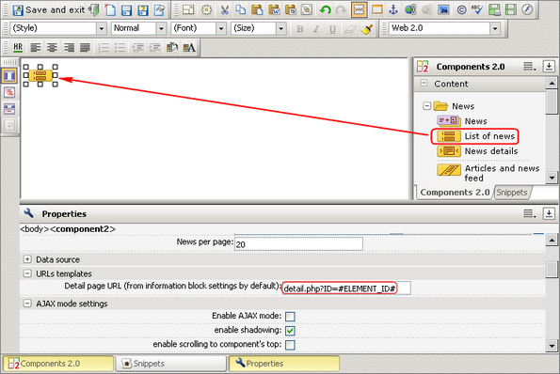
Fig. 3.15. Adding the news component
The List of news component displays the headlines of all the information block elements (news). The headlines are rendered as links to the news details page, regardless of the current user’s permissions.
- In the component property inspector, specify Paid Content as the information block type and Paid Articles as the information block code. Set the details page URL to detail.php (Fig. 3.15). We shall consider the creation of this page below.
- Click Save as… The file save dialog will open (Fig. 3.16).
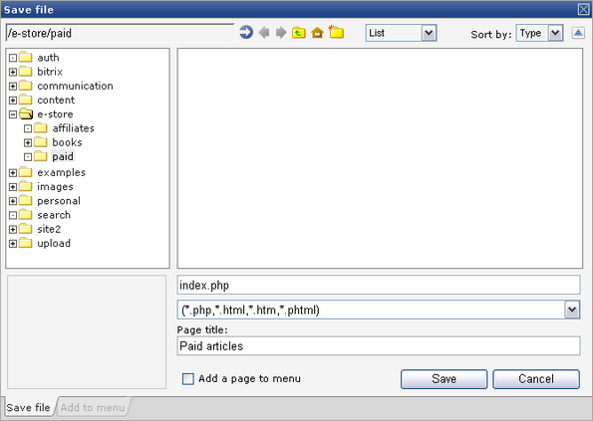
Fig. 3.16. File save gialog
- Type index.php in the file name field.
- Set the page title. It will be displayed in the page body in the public section.
- Click Save to save the page.

Creating the Full Article View Page
To display the full text of an information block element (news), we shall use the News details component.
- Click New file in the same folder (/e-store/paid/) to create a new page.
- Add the News details component to page (Fig. 3.17).
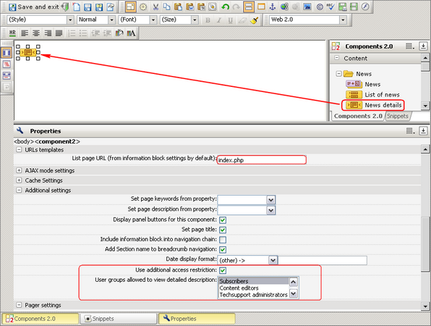
Fig. 3.17. Adding the “News details” component
- In the component properties, specify Paid Content as the information block type, and Paid Articles as the information block code. Set the articles page path (List page URL) to index.php.
- Mark the Set page title option. This will set the page title to the name of a current article.
Now we have to configure the following parameters to allow only the members of the Subscribers user group to view full articles (which is the paid content).
- Mark the Use additional access restrictions option. A list of the user groups will appear below.
- Select Subscribers in this list (рис. 3.3).
- Save the page under the name of detail.php.

Configuring Access Permissions For Selling
Now we have to make some amendments to allow only members of the Subscribers user group to access the full text of articles (in fact, the detail.php page). We shall use Site Explorer to configure the access permissions.
- In Control Panel, open Content > Site explorer > Files and folders > e-store > paid. A list of files will be displayed:
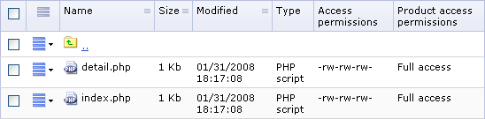
Fig. 4.18. Files in the paid content area
- Click the action menu icon beside the detail.php file and select the Access command in the menu. This will open the access management form (Fig. 4.19).
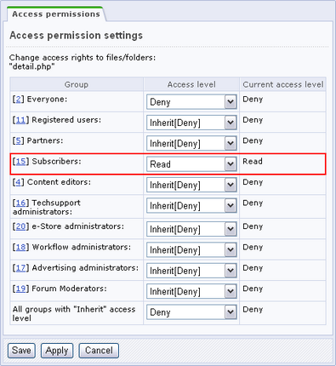
Fig. 4.19. Access permission management
- Assign the Read access permission for the Subscribers user group. To close access to full articles for other user groups, set their access level to Deny.
- Save changes.
- In order to enable selling access to the paid content, the settings of the Commercial Catalog module should be altered as well.
- Open the Commercial Catalog module settings page: Settings > System settings > Module settings > Commercial Catalog.
- Click the Permission Selling tab and check the option beside the Subscribers user group (Fig. 4.20).
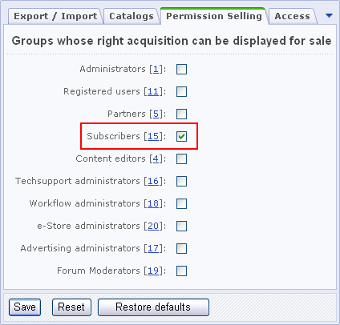
Fig. 4.20. Enabling to sell user group permissions
- Click Save.

Publishing the Subscription Catalog
In order to enable users subscribe for paid content, we have to display the subscription catalog in the public section. For example, the catalog can be published in an include area of the Paid Content section (/e-store/paid/):
- Open Content > Site Explorer > Files and Folders > e-store > paid in Control Panel.
- Click the New File button on the context toolbar to open the new file creation form.
- Select the Include area for section template. (If the visual editor opened immediately in fullscreen mode and you do not see the template selection field, click (Fullscreen) on the editor toolbar to revert to normal mode).
- In the visual editor, add the Section elements component to the page. It displays elements of a catalog section along with the specified properties and prices (Fig. 5.21).
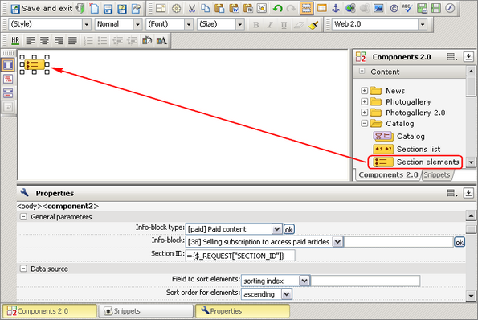
Fig. 5.21. The "Section elements" component
- Select the Paid Content information block type and click OK beside. Then, select the Selling subscription to access paid articles information block as the source of information.
- Now we would also want to show a shopping cart link below the subscriptions. To do so, add the Link to basket component. (Fig. 5.22). It shows the product items currently in basket and a customer cabinet link.
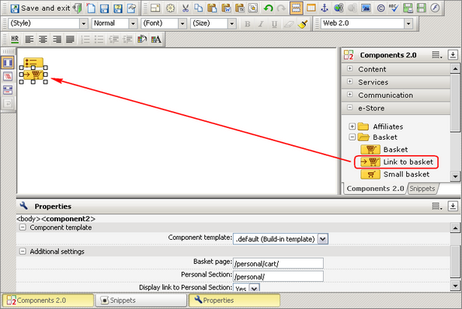
Fig. 5.22. Adding the "Link to basket" component
- Save the file as sect_inc.php.
After we have made the above described modifications, the index page of the Paid Content section would look as the following (Fig. 5.23):
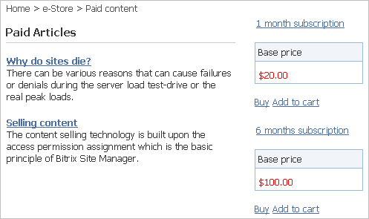
Fig. 5.23. The section index page
Members of the Subscribers group can view the article details page (Fig. 5.24). Other visitors will see the “Access denied” message and the authorization form when trying to view this page.
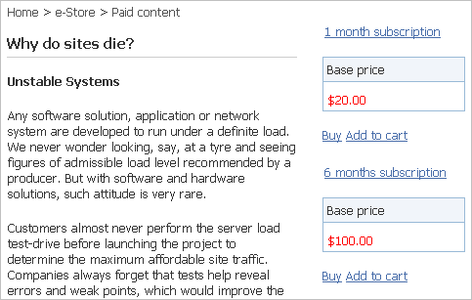
Fig. 5.24. The article details page
The section include area shows the subscription catalog items on all Paid Content pages.

Configuring the Web Store
Selling and receiving payments for the content are entirely under control of the e-Store module. We shall configure the parameters of these operations in the e-Store forms.
Note! Full configuration of the e-Store module (payer types, payment systems, credit cards etc.) is covered in the System Administration course. This tutorial only explains the configuration of permissions for orders.

Permissions for Orders
In this example, we shall entitle users having the Manage Orders access level to handle orders for content. This access level enables a person to process orders but denies any management access to the e-Store module.
- Open the e-Store module configuration page: Settings > System settings > Module settings > e-Store.
- Click the Order permissions tab.
- Select a user group whose members will be permitted to manage orders. For example, e-Store administrators.
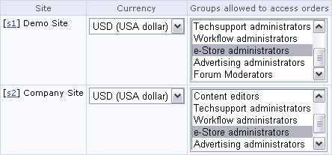
Fig. 6.25. Assigning permissions to user groups
Note! You must create the e-Store administrators group prior to giving it the access to orders. Assign a Manage orders access right to this user group in the user group settings form
.
Note! For each site, you can select an individual user group enabled to access orders.
- Click Save.
In order to inform clients and the web store staff about a current order state, the system provides order statuses. The following two types of statuses exist.
- Order states are the predefined entities that reflect a current processing status: Paid, Canceled, Delivery.
- Informational states reflect stages at which an order can be during processing. You can view the existing informational states on the Order statuses page. The system contains the two preset frontier states that cannot be deleted: Accepted and Delivered. However, you can create as many custom states as you want. For example: Processing, Shipped etc.
Eventually, the users who are members of the e-Store administrators group will take control of the orders. Hence, we have to configure their access rights for different order statuses.
- Open the Order Statuses page: e-Store > e-Store settings > Statuses.
For each status, perform the following actions to configure it.
- Open the status editing form (click on the action menu and select Modify status settings).
- Scroll to the Access permissions section (Fig. 6.26).
- Activate the options that are to be available to members of the e-Store administrators user group when an order is in this status (Fig. 6.26).
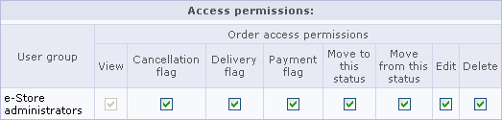
Fig. 6.26. Status permissions
- Click Save.
After you have finished the configuration, members of the e-Store administrators user group would be able to manage orders in any status.

Setting Up a Client’s Personal Area
The e-Store visual components give us the ultimate power to create pages where customers can view the basket items, order details, internal account, profiles; view and manage parameters of a recurring subscription payment etc. You can create pages in the visual HTML editor by adding components and tuning their parameters.
Note. You can find examples of personal area pages in /bitrix/modules/sale/install/public/.
Generally, the customers should be able to open the basket page by clicking a homonymous link, or the Buy button beside the product description. The basket page is the initial point in the order completion sequence, which is initiated by clicking Check out.

The Ordering Procedure
Setting up the order completion page is simple; follow the steps below.
- Create a new page in a required site section.
- Add the Ordering Procedure component to the page (Fig. 7.27).
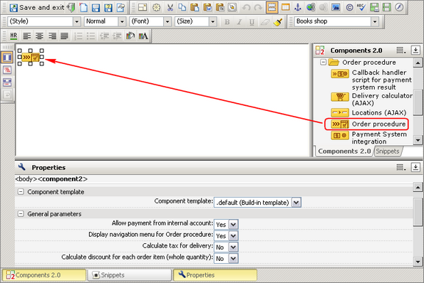
Fig. 7.27. Adding the "Ordering Procedure" component
- Configure the component parameters as required.
- Save the page.
Important! Remember to specify the path to this page in the Basket component parameters.
Eventually, we have the order check-out page in the public section:
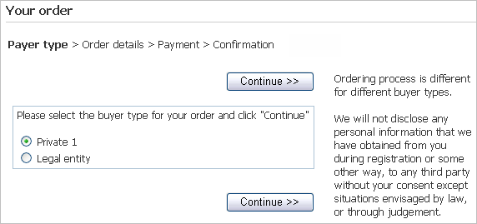
Fig. 7.28. The check-out page

Managing Orders
After an order has been placed, a corresponding record appears in the orders page: e-Store > Orders (Fig. 8.29).
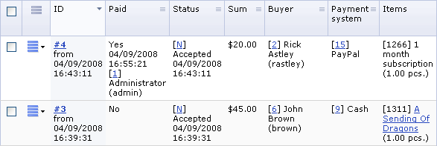
Fig. 8.29. The orders page
The following user groups are permitted to manage orders:
- the site administrators;
- the web store administrators;
- any user group that is allowed to access orders in a certain status.
The only reason for the product delivery (which essentially means adding a customer to an appropriate user group) is changing the order status to Delivery (see Fig. 8.30). The status can be changed in the order details page which can be opened by selecting View order details in the action menu.
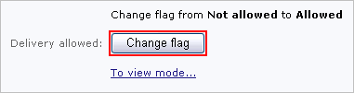
Fig. 8.30. Changing the order status
An order can be moved to the Paid status:
- automatically if a payment system chosen by a client is able to return the processing result immediately;
- manually (upon receipt of money): by changing the status from Not paid to Paid in the order details form (Fig. 8.31).
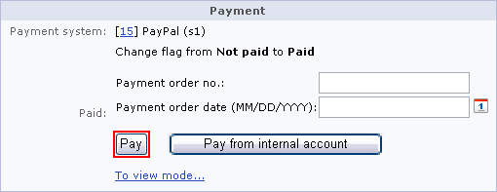
Fig. 8.31. Order payment
The Pay from internal account option can be used on the stipulation that the client’s internal account has enough money and they can be withdrawn for payment.
Note! All transactions occurring during payment are registered by the system. You can view the transactions here: e-Store > Customers accounts > Transaction.

